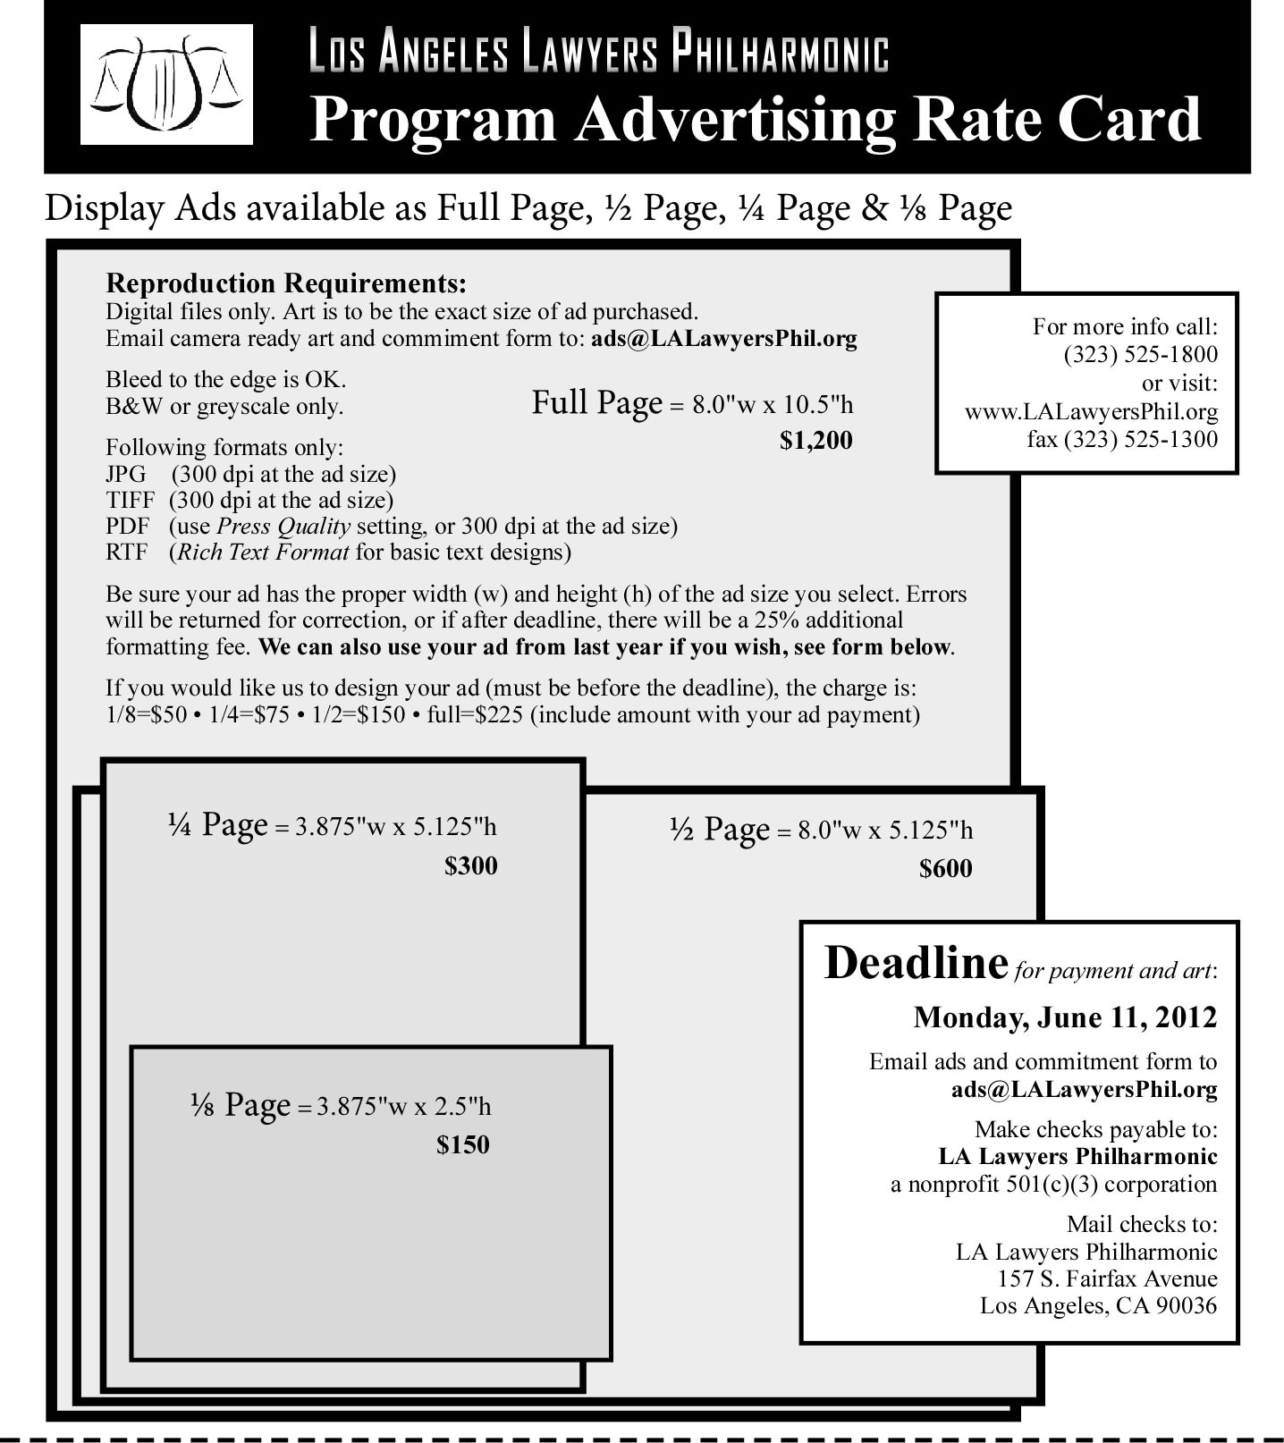

Program Commitment Form: (enter how many ads you want of each size, or X Use Last and we will use your ad from last year)

___Full Page @ $1200 each (8" wide x 10.5" high) ___1/4 Page @ $300 each (3.875" wide x 5.125" high)
___1/2 Page @ $600 each (8" wide x 5.125" high) ___1/8 Page @ $150 each (3.875" wide x 2.5" high)

___Use Last Year’s ad artwork

Firm Name:

Address City: State: Zip:

Contact Name: Phone: Email:

